EXPERIMENT : 5

DATA VISUALIZATION USING MATPLOTLIB

AIM
To create and analyze various data visualizations such as Line Charts, Bar Charts, Pie Charts, Histograms, Scatter Plots, and Box Plots using Matplotlib for effective data interpretation.

ALGORITHM
Step 1: Import the required Python libraries such as Pandas, NumPy, and Matplotlib.
Step 2: Load the KaggleV2-May-2016.csv dataset into a Pandas DataFrame.
Step 3: Display and inspect the dataset.
Step 4: Create a Line Chart to visualize appointments by age.
Step 5: Create a Bar Chart to compare appointments by gender.
Step 6: Create a Pie Chart to visualize the no-show distribution.
Step 7: Create a Histogram to show the age distribution of patients.
Step 8: Create Scatter Plots to analyze relationships between age and other numerical variables.
Step 9: Create a Box Plot to identify the distribution and possible outliers in patient age.
Step 10: Create a Multiple Line Chart to compare diabetes and hypertension across different age groups.
Step 11: Create additional Bar and Pie Charts for neighbourhood, scholarship, and no-show analysis.
Step 12: Convert the appointment date into a date format and create a Line Chart showing the monthly appointment trend.
Step 13: Add appropriate titles, axis labels, legends, and percentage labels to the visualizations.
Step 14: Display and interpret all the generated visualizations.

CODE

# ============================================================
# EXPERIMENT 5 - DATA VISUALIZATION USING MATPLOTLIB
# Dataset: KaggleV2-May-2016.csv
# ============================================================

import pandas as pd
import numpy as np
import matplotlib.pyplot as plt

# ------------------------------------------------------------
# 1. IMPORT DATASET
# ------------------------------------------------------------

df = pd.read_csv("/content/KaggleV2-May-2016.csv")

print("First 5 rows of the dataset:")
print(df.head())

print("\nDataset Shape:")
print(df.shape)

# ------------------------------------------------------------
# 2. LINE CHART - APPOINTMENTS BY AGE
# ------------------------------------------------------------

age_counts = df["Age"].value_counts().sort_index()

plt.figure(figsize=(10, 5))
plt.plot(age_counts.index, age_counts.values)

plt.title("Appointments by Age")
plt.xlabel("Age")
plt.ylabel("Number of Appointments")

plt.show()

# ------------------------------------------------------------
# 3. BAR CHART - APPOINTMENTS BY GENDER
# ------------------------------------------------------------

gender_counts = df["Gender"].value_counts()

plt.figure(figsize=(6, 5))
plt.bar(gender_counts.index, gender_counts.values)

plt.title("Appointments by Gender")
plt.xlabel("Gender")
plt.ylabel("Number of Appointments")

plt.show()

# ------------------------------------------------------------
# 4. PIE CHART - NO-SHOW DISTRIBUTION
# ------------------------------------------------------------

no_show_counts = df["No-show"].value_counts()

plt.figure(figsize=(6, 6))
plt.pie(
no_show_counts,
labels=no_show_counts.index,
autopct="%1.1f%%"
)

plt.title("No-Show Distribution")

plt.show()

# ------------------------------------------------------------
# 5. HISTOGRAM - AGE DISTRIBUTION
# ------------------------------------------------------------

plt.figure(figsize=(8, 5))
plt.hist(df["Age"], bins=20)

plt.title("Patient Age Distribution")
plt.xlabel("Age")
plt.ylabel("Frequency")

plt.show()

# ------------------------------------------------------------
# 6. SCATTER PLOT - AGE VS SMS RECEIVED
# ------------------------------------------------------------

plt.figure(figsize=(8, 5))
plt.scatter(
df["Age"],
df["SMS_received"],
alpha=0.3
)

plt.title("Age vs SMS Received")
plt.xlabel("Age")
plt.ylabel("SMS Received")

plt.show()

# ------------------------------------------------------------
# 7. SCATTER PLOT - AGE VS APPOINTMENT ID
# ------------------------------------------------------------

plt.figure(figsize=(8, 5))
plt.scatter(
df["Age"],
df["AppointmentID"],
alpha=0.3
)

plt.title("Age vs Appointment ID")
plt.xlabel("Age")
plt.ylabel("Appointment ID")

plt.show()

# ------------------------------------------------------------
# 8. BOX PLOT - AGE
# ------------------------------------------------------------

plt.figure(figsize=(6, 5))
plt.boxplot(df["Age"])

plt.title("Age Distribution and Outliers")
plt.ylabel("Age")

plt.show()

# ------------------------------------------------------------
# 9. BOX PLOT - AGE BY GENDER
# ------------------------------------------------------------

male_age = df[df["Gender"] == "M"]["Age"]
female_age = df[df["Gender"] == "F"]["Age"]

plt.figure(figsize=(7, 5))
plt.boxplot(
[male_age, female_age],
labels=["Male", "Female"]
)

plt.title("Age Distribution by Gender")
plt.xlabel("Gender")
plt.ylabel("Age")

plt.show()

# ------------------------------------------------------------
# 10. MULTIPLE LINE CHARTS - DIABETES AND HYPERTENSION
# ------------------------------------------------------------

age_group = df.groupby("Age")[["Diabetes", "Hipertension"]].mean()

plt.figure(figsize=(10, 5))

plt.plot(
age_group.index,
age_group["Diabetes"],
label="Diabetes"
)

plt.plot(
age_group.index,
age_group["Hipertension"],
label="Hypertension"
)

plt.title("Diabetes and Hypertension by Age")
plt.xlabel("Age")
plt.ylabel("Average Value")

plt.legend()

plt.show()

# ------------------------------------------------------------
# 11. BAR CHART - TOP 10 NEIGHBOURHOODS
# ------------------------------------------------------------

neighbourhood_counts = df["Neighbourhood"].value_counts().head(10)

plt.figure(figsize=(12, 5))
plt.bar(
neighbourhood_counts.index,
neighbourhood_counts.values
)

plt.title("Top 10 Neighbourhoods by Appointments")
plt.xlabel("Neighbourhood")
plt.ylabel("Number of Appointments")

plt.xticks(rotation=45)

plt.show()

# ------------------------------------------------------------
# 12. PIE CHART - SCHOLARSHIP DISTRIBUTION
# ------------------------------------------------------------

scholarship_counts = df["Scholarship"].value_counts()

plt.figure(figsize=(6, 6))

plt.pie(
scholarship_counts,
labels=["No Scholarship", "Scholarship"],
autopct="%1.1f%%"
)

plt.title("Scholarship Distribution")

plt.show()

# ------------------------------------------------------------
# 13. BAR CHART - NO-SHOW BY GENDER
# ------------------------------------------------------------

gender_noshow = pd.crosstab(
df["Gender"],
df["No-show"]
)

plt.figure(figsize=(7, 5))

gender_noshow.plot(kind="bar")

plt.title("No-Show by Gender")
plt.xlabel("Gender")
plt.ylabel("Number of Patients")

plt.xticks(rotation=0)

plt.show()

# ------------------------------------------------------------
# 14. LINE CHART - MONTHLY APPOINTMENT TREND
# ------------------------------------------------------------

df["AppointmentDay"] = pd.to_datetime(df["AppointmentDay"])

monthly_appointments = (
df.groupby(df["AppointmentDay"].dt.to_period("M"))
.size()
)

plt.figure(figsize=(10, 5))

plt.plot(
monthly_appointments.index.astype(str),
monthly_appointments.values
)

plt.title("Monthly Appointment Trend")
plt.xlabel("Month")
plt.ylabel("Number of Appointments")

plt.xticks(rotation=45)

plt.show()

# ============================================================
# END OF EXPERIMENT 5
# ============================================================

print("\nExperiment 5 completed successfully!")

OUTPUT

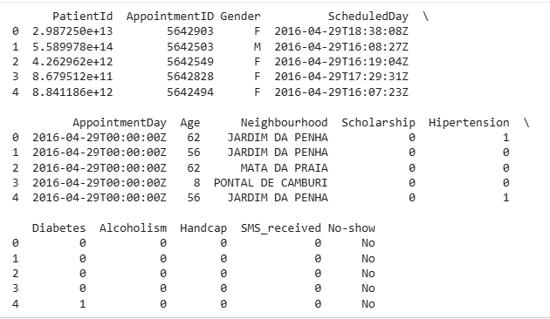

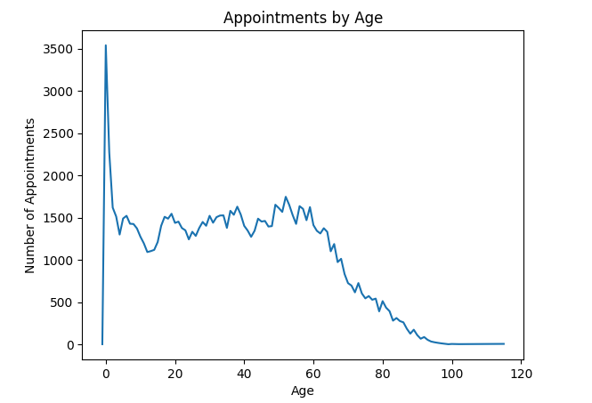

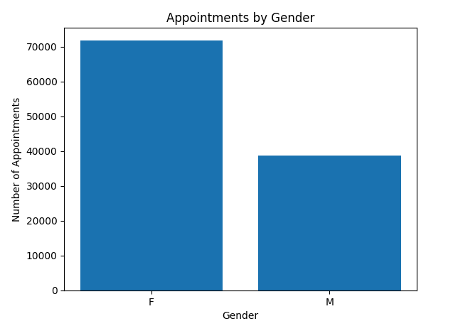

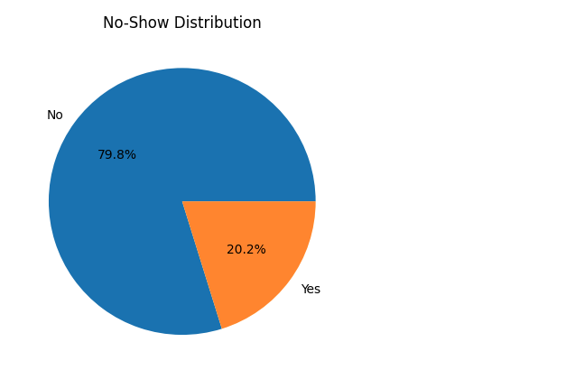

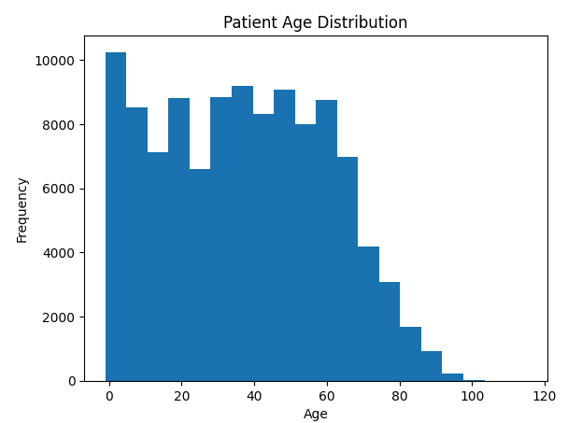

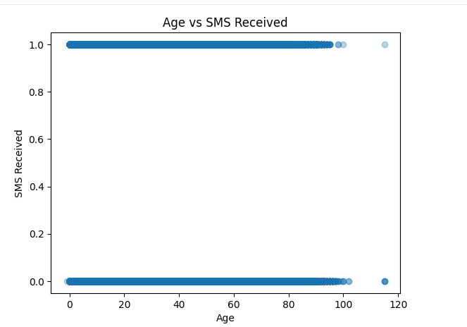
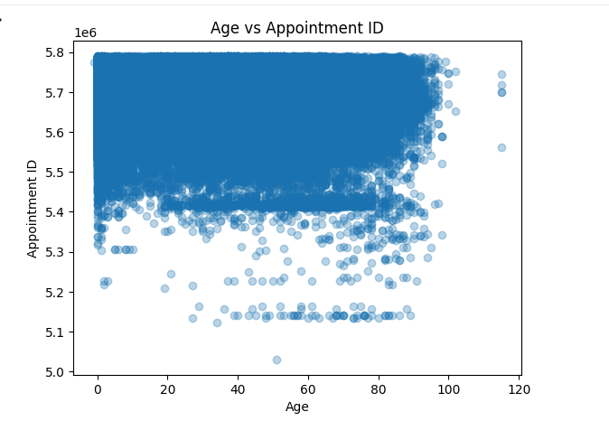
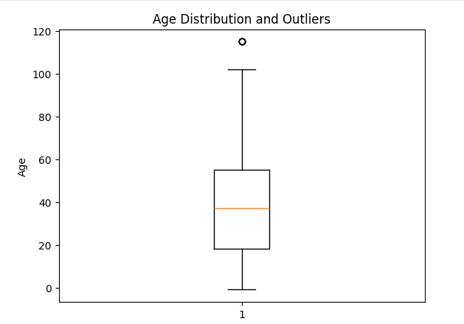
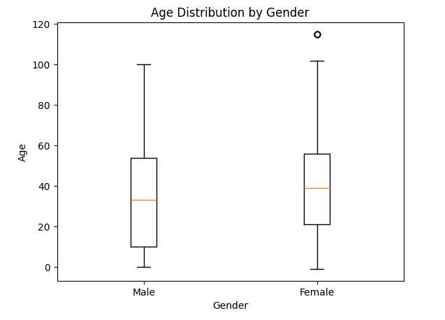
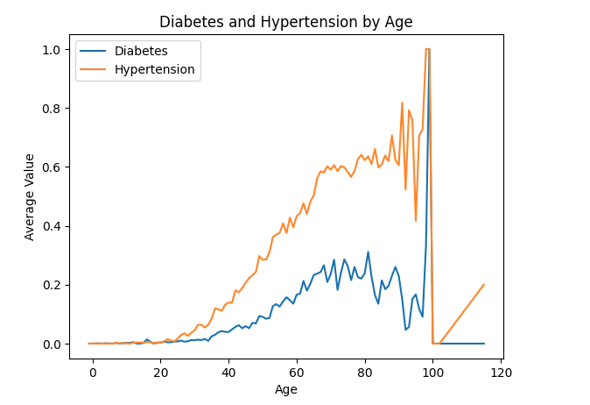
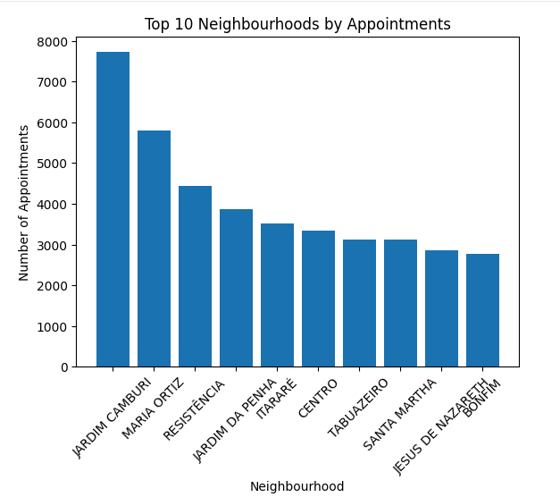

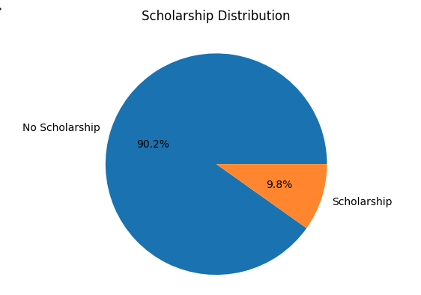
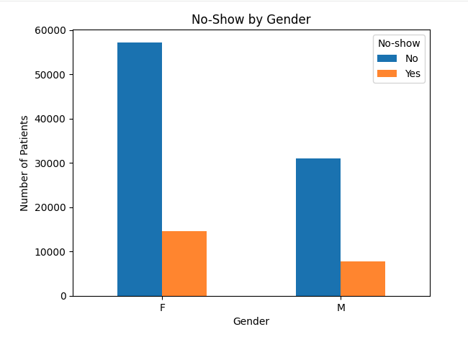
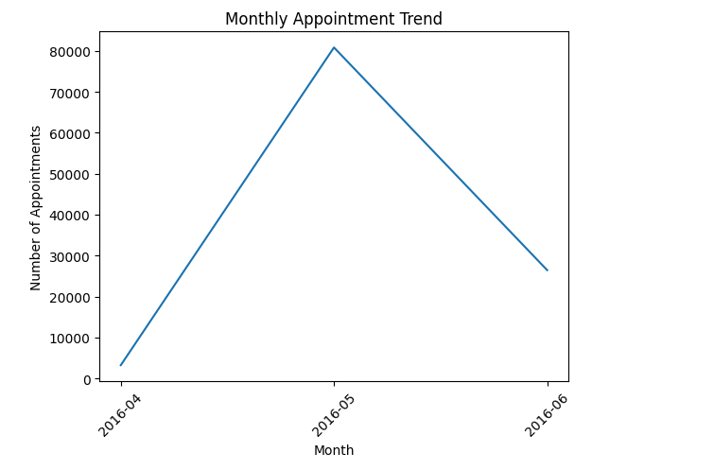

RESULT
Thus, various data visualization techniques such as Line Charts, Bar Charts, Pie Charts, Histograms, Scatter Plots, Box Plots, and Multiple Line Charts were successfully created using Matplotlib on the healthcare appointment dataset. The visualizations helped in understanding patient age distribution, gender distribution, no-show patterns, medical conditions, neighbourhood appointments, and monthly appointment trends.

